**CSEE5590/490: Web/Mobile Programming**

**Report for Lab programming-II**



**Prepared By**

**Praneeth Thota- 15**

**Tummanapalli Samhitha- 18**

**Pillala NavyaRamyaSirisha13**

**Index**

**Contents Page No.**

1. Introduction
2. Objective
3. Approaches/Methods
4. Workflow
5. Evaluation & Discussion
6. Conclusion
7. References

**Introduction:**

This report is about the Lab 2 which is to focus on to make one familiar with MEAN stack application and basic mobile application programming

**Objective:**

The main Objective for this Lab is to perform two tasks and those tasks are as described below

1. To Create and manage user authentication in MEAN stack application by considering the following features:

a. Let a user register

b. Save their data

c. Let the returning user log in

d. Keep a logged in user's session alive between page visits

e. Have some pages that can only be seen by logged in users

f. Change output to the screen depending on logged in status (e.g. a "login" button or a "my profile" button)

2. Create a mobile application by considering the following features. The application should have good UI/UX

a. Include features such as login, signup, and social login

b. After login, the application should display a welcome message with user details (e.g., username, gender, university, branch, profile image etc.). No limit on user details, you can use your creativity on this screen.

c. It should have a logout button

**Approaches/Methods:**

The approaches or tools that are used are

* Android Studio
* Mean Stack

**Workflow:**

The Workflow is to explain the code snippets and Output images for all the three tasks

**TASK 1:**

This image depicts the details about the Local host

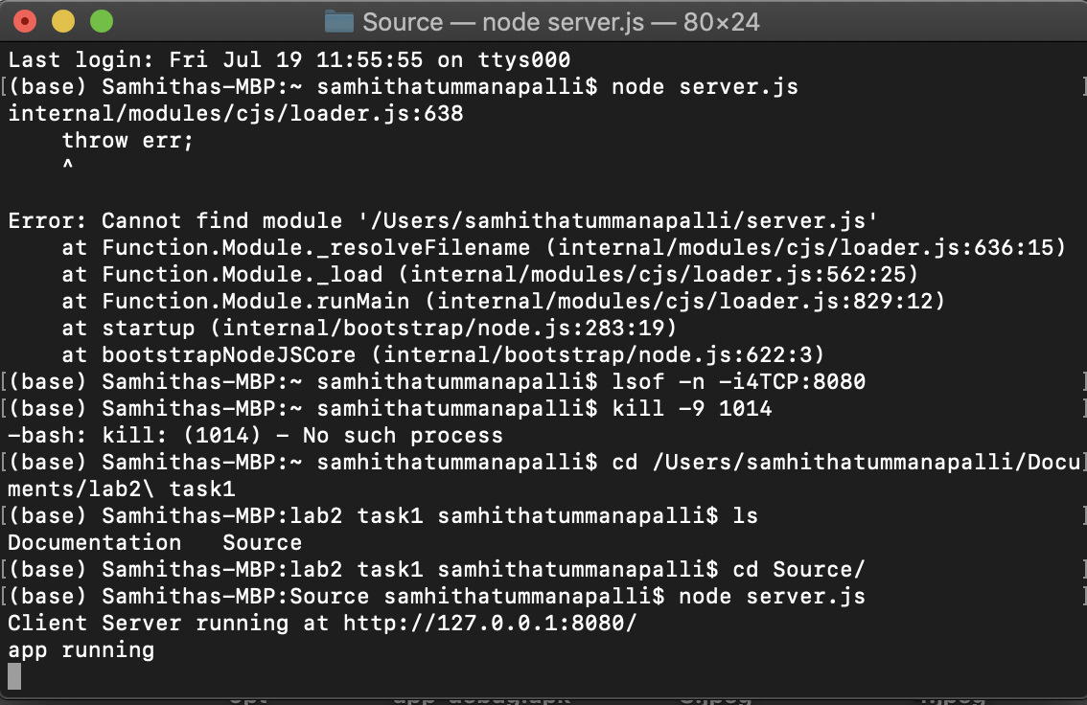

This image explains about the database clusters where we are storing the details of the user

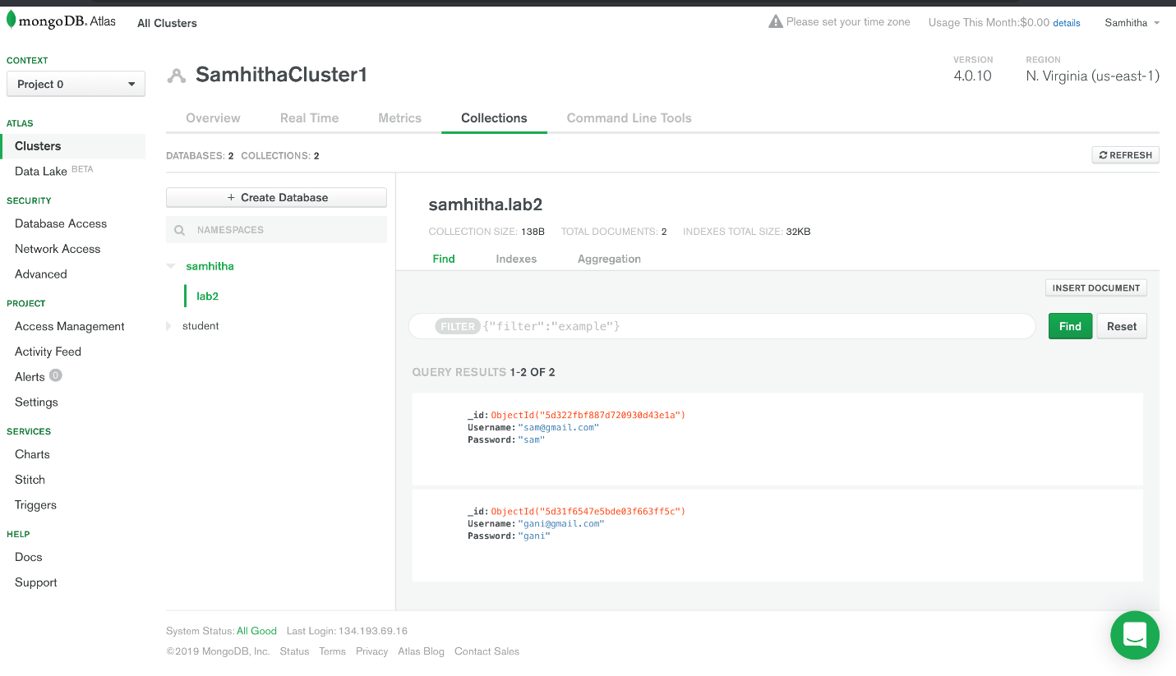

This image explains us about the Login and register page

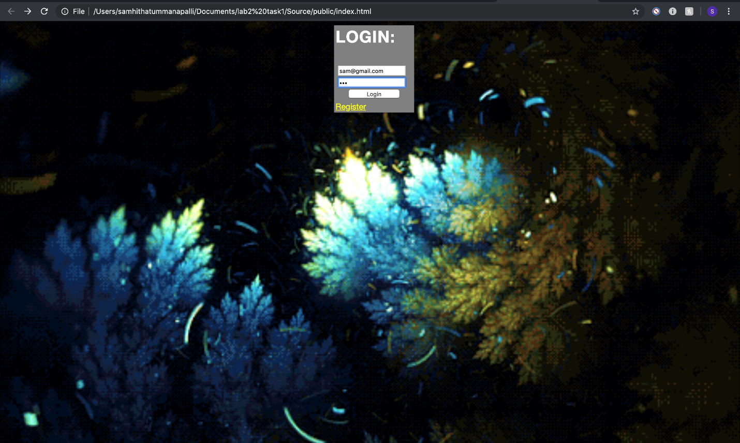

This image explains about the User details

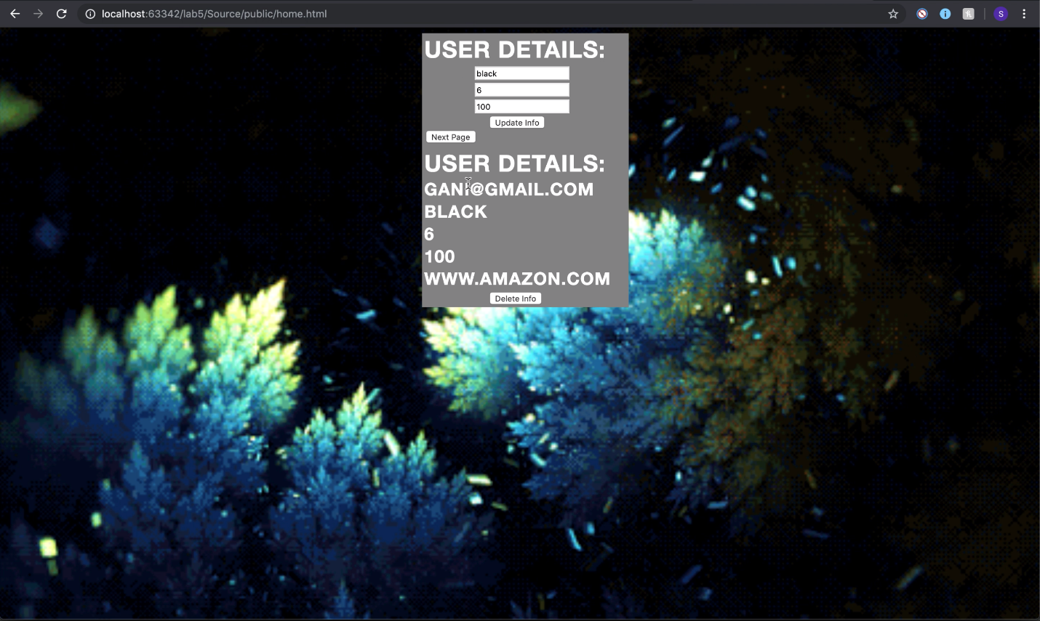

This image explains about the delete feature.

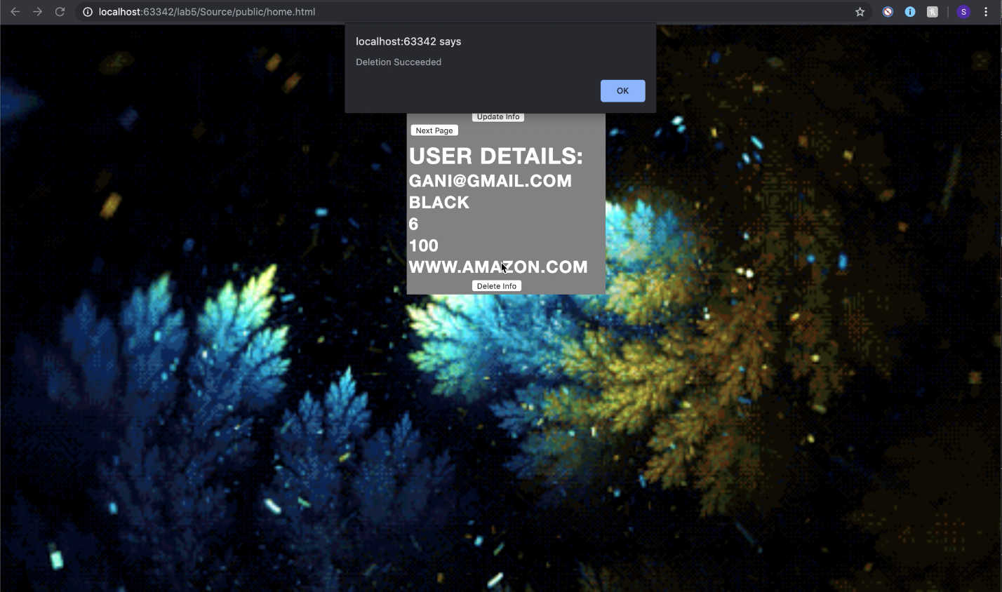

This image depicts the details about the registration of the user

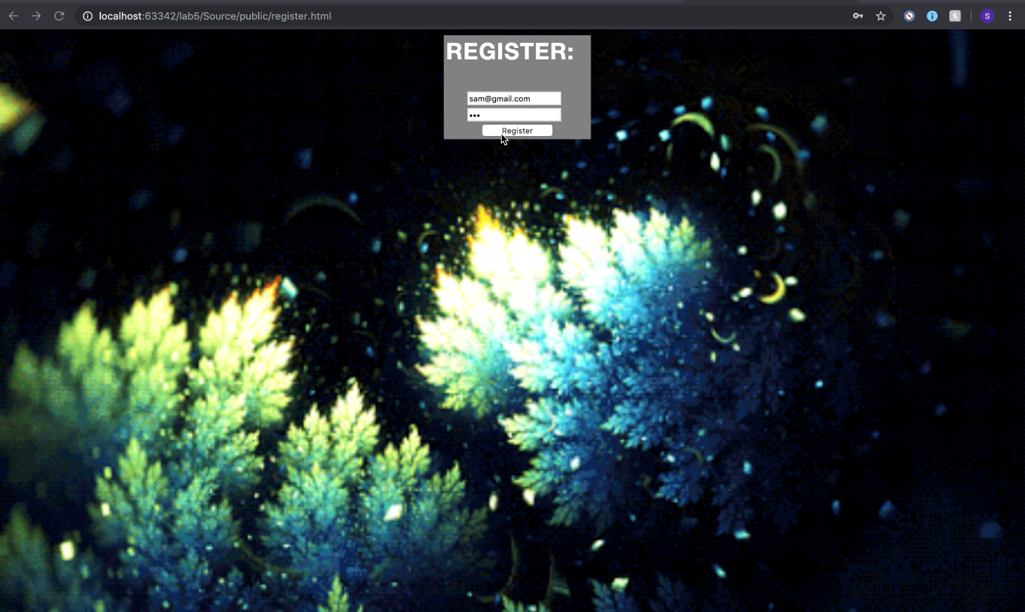

This image shows that the registered user details are stored in the Database

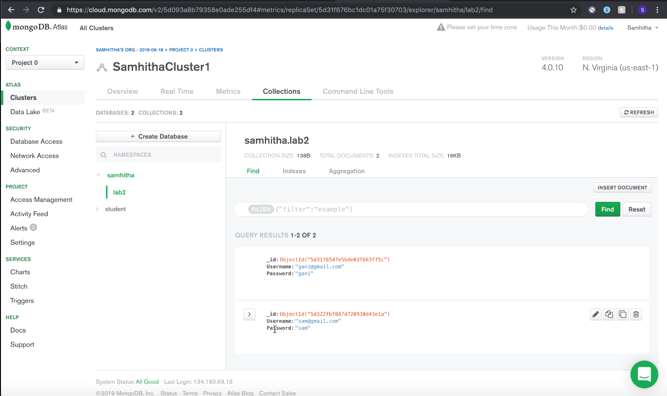

This image is to explain that the user can come back and again login

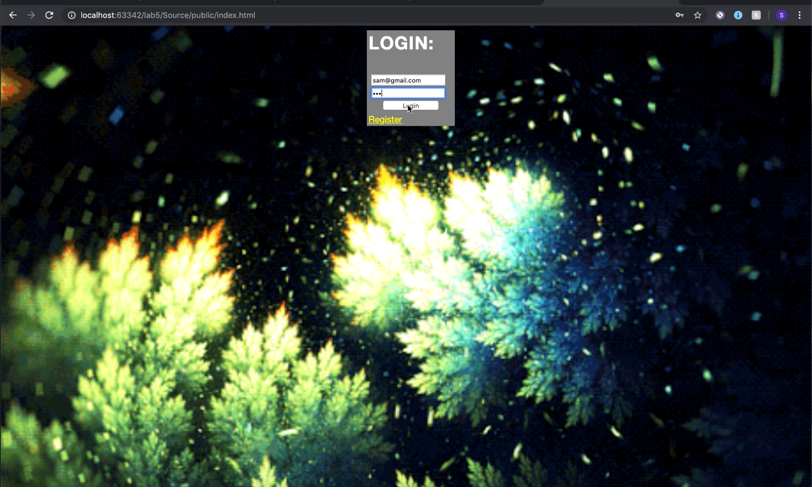

This is the image that only the loggedIn User can see the details

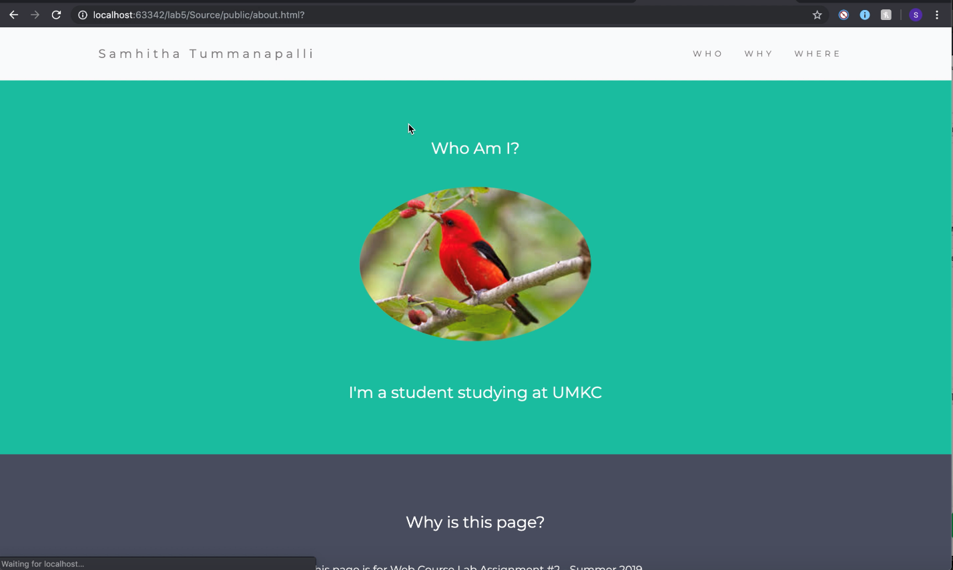

**TASK 2:**

This image explains the details about the mobile application with Login, signup and social signin.

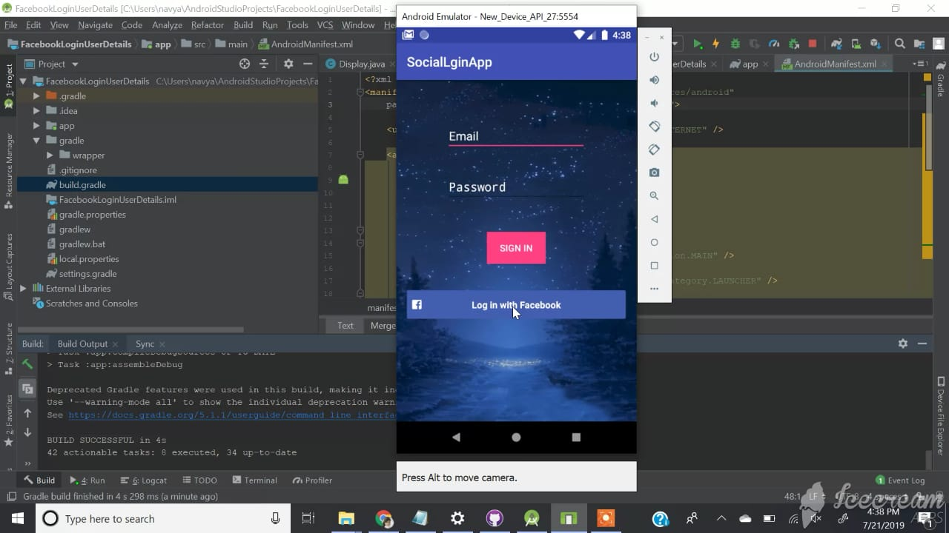

This image is to display the Facebook Login.

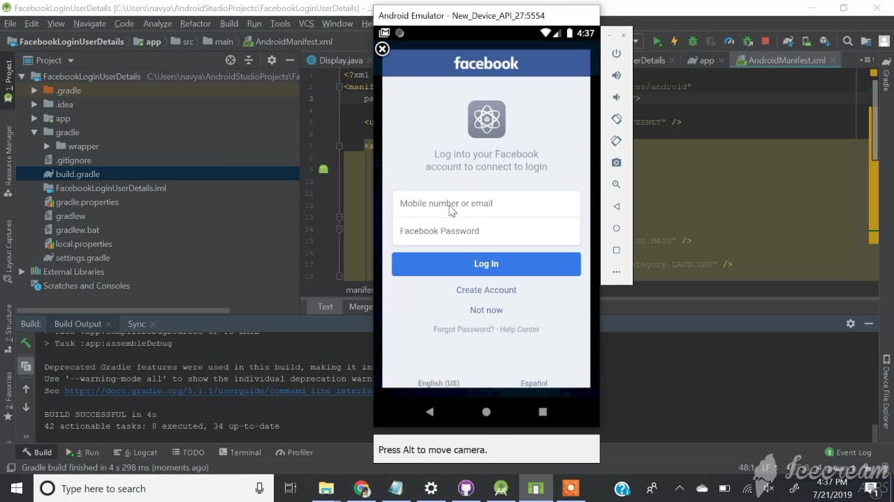

This image is to depict the detail about the logout

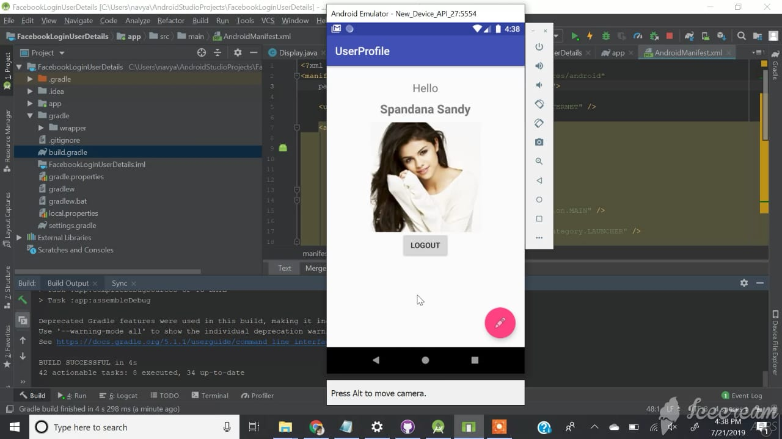

This image redirects the page to the home page after we logout

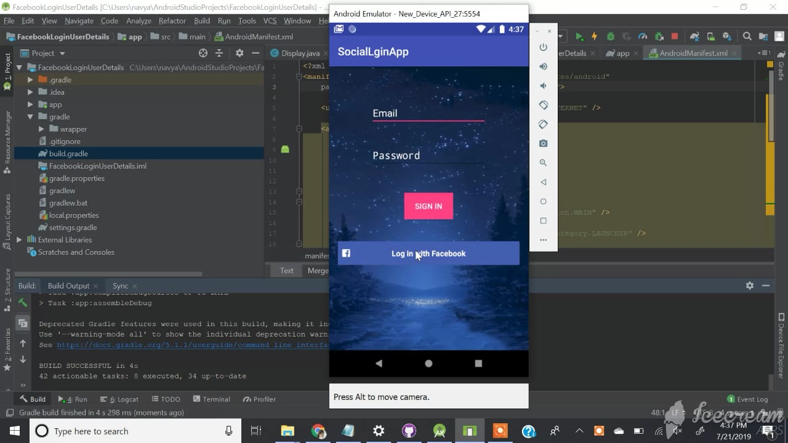

**Evaluation & Discussion:**

**Here,** I am giving the explanation and youtube video for the LAB

https://youtu.be/BnMJH3LjXpk

**Conclusion:** Hereby, We conclude that we totally understood the concept of Meanstack and Android Application

**References:**

* <https://kgsearch.googleapis.com/v1/entities:search?query=taylor+swift&key=API_KEY&limit=1&indent=True>
* **https://developers.google.com/knowledge-graph/**
* <https://www.w3schools.com/>